CREATE DATABASE company;
USE company;

CREATE TABLE employees (
emp_id INT PRIMARY KEY AUTO_INCREMENT,
emp_name VARCHAR(100),
gender VARCHAR(10),
hire_date DATE,
department_id INT
);
SELECT * FROM employees;

CREATE TABLE departments (
department_id INT PRIMARY KEY AUTO_INCREMENT,
department_name VARCHAR(50),
location VARCHAR(50)
);

CREATE TABLE salaries (
salary_id INT PRIMARY KEY AUTO_INCREMENT,
emp_id INT,
basic_salary INT,
bonus INT,
FOREIGN KEY (emp_id) REFERENCES employees(emp_id)
);

CREATE TABLE attendance (
attendance_id INT PRIMARY KEY AUTO_INCREMENT,
emp_id INT,
attendance_date DATE,
status ENUM('Present', 'Absent'),
FOREIGN KEY (emp_id) REFERENCES employees(emp_id)
);

INSERT INTO departments (department_name, location)
VALUES
('IT', 'Chennai'),
('HR', 'Bangalore'),
('Finance', 'Mumbai');

INSERT INTO employees (emp_name, gender, hire_date, department_id)
VALUES
('Ravi Kumar', 'Male', '2021-01-10', 1),
('Anita Sharma', 'Female', '2021-08-15', 2),
('Sheela', 'Female', '2021-11-05', 3),
('Vijay, 'Male', '2022-03-14', 4)
('Vikram Singh', 'Male', '2022-07-12', 5),
('Vimala Raman', 'Female', '2022-11-09', 6);

INSERT INTO salaries (emp_id, basic_salary, bonus)
VALUES
(1, 50000, 5000),
(2, 45000, 3000),
(3, 50000, 5000),
(4, 35000, 2000),
(5, 45000, 5000),
(6, 60000, 7000);

INSERT INTO attendance (emp_id, attendance_date, status)
VALUES
(1, '2024-03-01', 'Present'), (2, '2024-03-01', 'Present'), (3, '2024-03-01', 'Present'), (4, '2024-03-01', 'Absent'), (5, '2024-03-01', 'Present'), (6, '2024-03-01', 'Present'),
(1, '2024-03-02', 'Absent'), (2, '2024-03-02', 'Present'), (3, '2024-03-02', 'Present'), (4, '2024-03-02', 'Present'), (5, '2024-03-02', 'Absent'), (6, '2024-03-02', 'Absent');

SELECT * FROM employees;
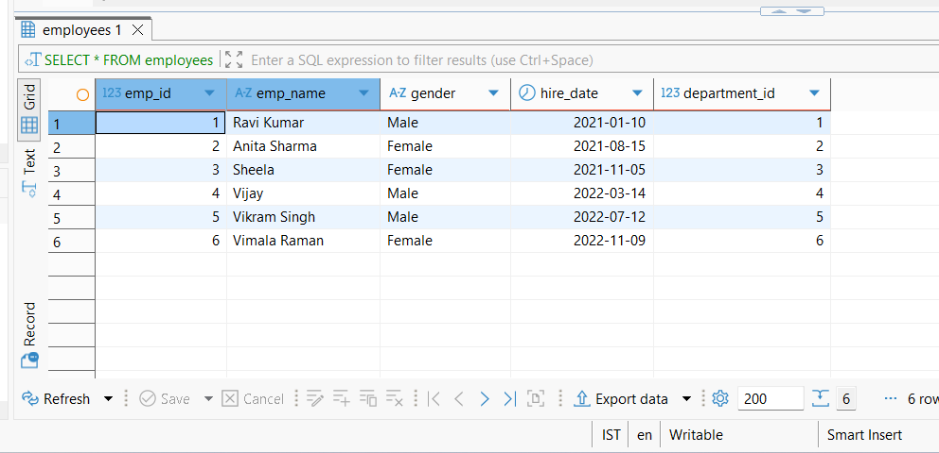
SELECT * FROM departments;
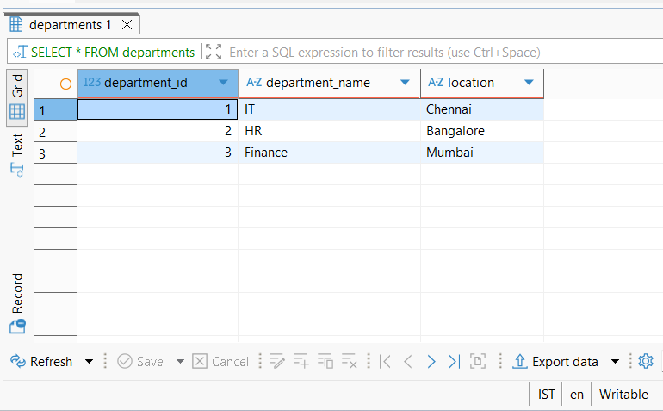
SELECT * FROM salaries;
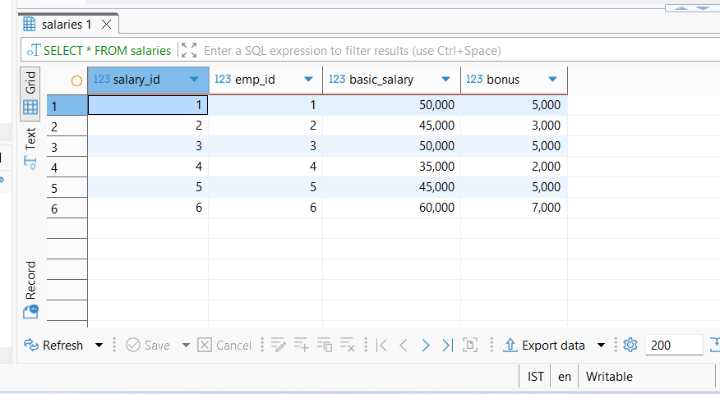
SELECT * FROM attendance;
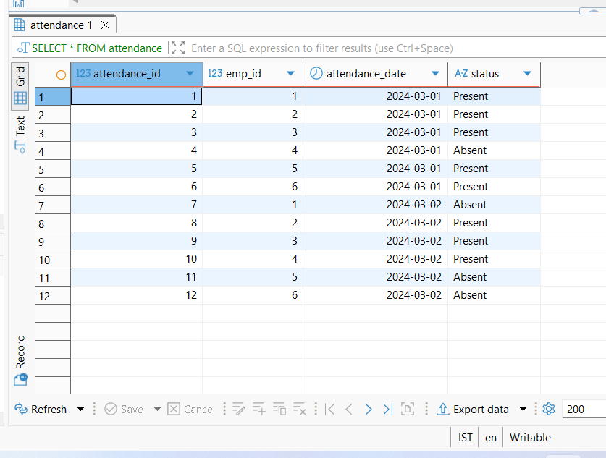
SELECT
e.emp_name,
d.department_name
FROM employees e
JOIN departments d ON e.department_id = d.department_id;
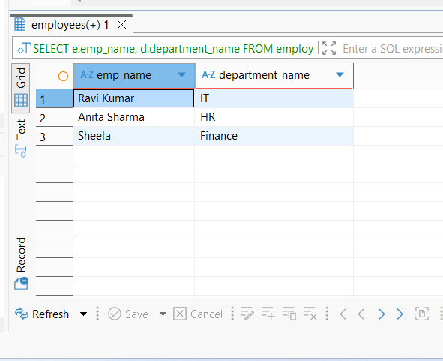

SELECT
e.emp_name,
s.basic_salary,
s.bonus,
(s.basic_salary + s.bonus) AS total_salary
FROM salaries s
JOIN employees e ON s.emp_id = e.emp_id;
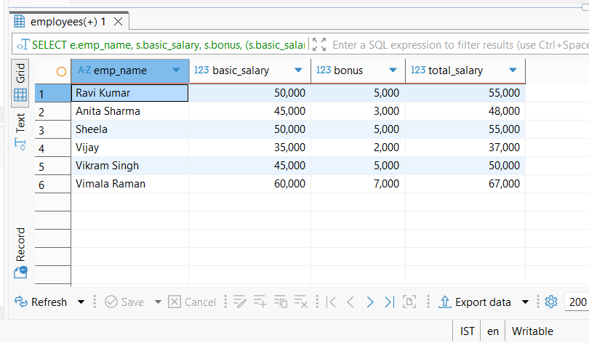

SELECT emp_name
FROM employees
WHERE department_id = (
SELECT department_id FROM departments WHERE department_name = 'IT'
);
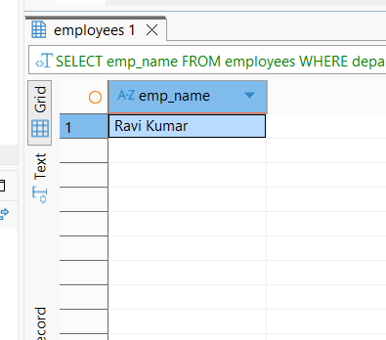

SELECT
e.emp_name,
COUNT(a.status) AS days_present
FROM attendance a
JOIN employees e ON a.emp_id = e.emp_id
WHERE a.status = 'Present'
GROUP BY e.emp_name;
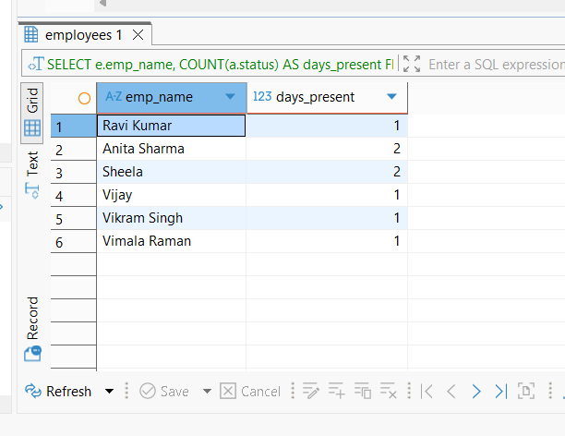

SELECT
e.emp_name,
(s.basic_salary + s.bonus) AS total_salary
FROM salaries s
JOIN employees e ON s.emp_id = e.emp_id
ORDER BY total_salary DESC
LIMIT 1;
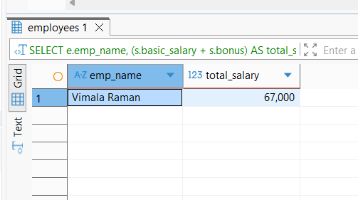

SELECT
d.department_name,
SUM(s.basic_salary + s.bonus) AS total_expense
FROM salaries s
JOIN employees e ON s.emp_id = e.emp_id
JOIN departments d ON e.department_id = d.department_id
GROUP BY d.department_name;
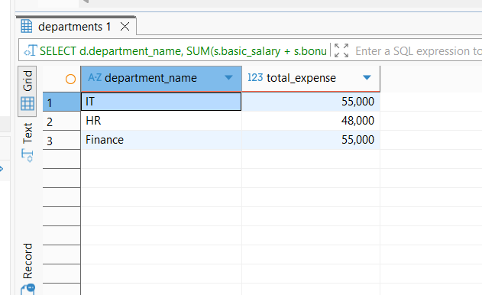

SELECT e.emp_name
FROM employees e
LEFT JOIN attendance a ON e.emp_id = a.emp_id
WHERE a.emp_id IS NULL;

